BELIZE MACRO-SOCIO-ECONOMIC DATA

Economic Indicators
 | 2019 | 2020 | 2021 | 2020 | 2023 | 2024 | 2025
Population (000’s) | 386.1 | 393.0 | 399.4 | 397.5 | 404.2 | 410.9 | 415.0
Employed Labour Force (000’s) | 167.7 | 134.9 | 154.7 | 162.4 | 164.8 | 164.3 | 179.0
Unemployment Rate (%) | 9.0 | 13.8 | 10.3 | 5.1 | 3.3 | 2.5 | 2.0
GDP at Current Market Prices ($mn) | 4,762.4 | 4,094.6 | 4,857.2 | 5,693.2 | 6,104.7 | 6,407.3 | 6,655.8
GDP at Constant 2014 Prices ($) | 4,533.7 | 3,920.6 | 4,625.9 | 5,053.9 | 5,079.1 | 5,257.1 | 5,401.6
GDP Per Capita at Current Market Prices ($) | 12,333.9 | 10,418.8 | 12,162.1 | 14,323.1 | 15,103.3 | 15,592.5 | 16,037.3
Sectoral Distribution of Constant GDP (%)
Primary | 9.9 | 10.8 | 11.3 | 10.3 | 9.6 | 9.5 | 10.0
Secondary | 13.9 | 16.2 | 15.9 | 14.5 | 14.2 | 14.2 | 14.0
Tertiary | 63.5 | 61.3 | 60.6 | 61.3 | 62.6 | 63.2. | 63.3

Macroeconomic Context

Economic Growth

Belize’s post-independence economic growth performance has been characterized by periods of economic expansion punctuated by elevated volatility and increasing exposure to external shocks. Between 1980 and the early 1990s, the economy experienced several episodes of robust growth, including multiple years of double-digit expansion in economic activity (Figure 1 – Panel 1). This performance was driven primarily by agricultural expansion, diversification into tourism services and public sector investment. Growth, however, moderated significantly thereafter, particularly following the global financial crisis, with the post-2008 period characterized by lower average growth and repeated episodes of economic contraction. Over time, the economy has become increasingly vulnerable to global economic fluctuations, natural disasters and commodity price shocks. These vulnerabilities culminated in 2020, when, amid the COVID-19 pandemic, Belize recorded its largest economic contraction in recent history, with output declining by 13.5% percent.

Figure 1:
Belize Real GDP Growth, Annual percentage and 5-Year Average (1980 – 2025)
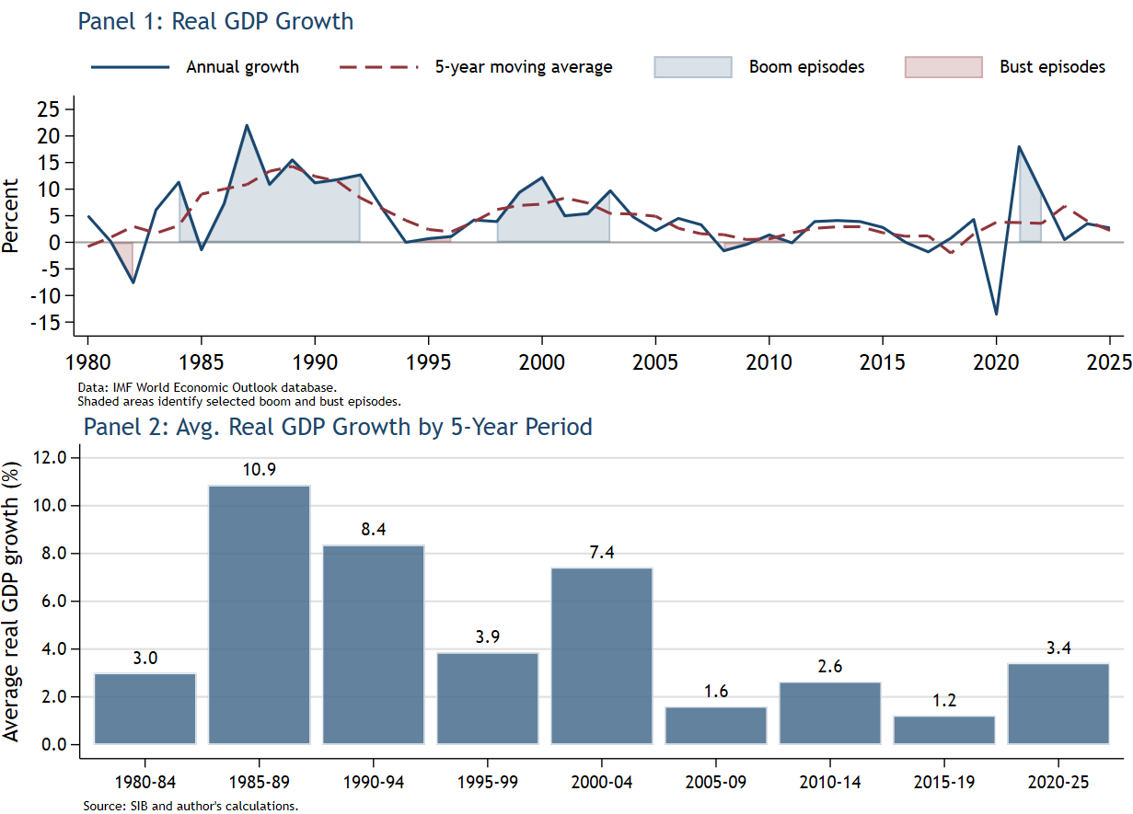

Despite registering a strong post-pandemic recovery, growth is projected to return to its estimated medium-term potential of approximately 2 percent or below. Real GDP expanded by 17.9% in 2021, 8.7% in 2022 and 4.7% in 2023, supported by the rebound in tourism activity, increased construction and continued expansion of the business process outsourcing (BPO) sector. Notwithstanding, the broader growth trend suggests weakening economic dynamism, modest productivity improvements and limited structural transformation.

Panel 2 highlights a pronounced deceleration in Belize’s long-run growth trajectory over the past four decades. Average real GDP growth increased from 3.0% during 1980-84 to 10.9% in 1985-89, representing the strongest sustained period of expansion in the country’s post-independence history. Growth remained relatively strong during 1990-94, averaging 8.4%, before moderating to 3.9% during 1995-99. Although growth rebounded to 7.4% in 2000-04, this momentum was short lived. From 2005 onward, Belize appears to have transitioned into a structurally lower-growth equilibrium, with average growth declining to 1.6% during 2005-09 and remaining subdued thereafter. While average growth recovered to 3.4% during 202-25, this largely reflects the rebound from the pandemic-induced contraction rather than a fundamental strengthening of the economy’s long-term growth potential.

Overall, the evidence suggests that Belize has moved from a high-growth convergence phase toward a more mature low-growth equilibrium characterized by weaker productivity growth, reduced structural dynamism, and heightened macroeconomic vulnerability. This pattern is consistent with concerns regarding declining total factor productivity, limited export diversification, low investment efficiency, and persistent labour market constraints. These macroeconomic trends have important implications for labour market outcomes, as prolonged periods of weak and volatile growth tend to constrain employment generation, reduce productivity gains, and exacerbate labour market insecurity, particularly among youth, women, and workers concentrated in tourism- and agriculture-dependent sectors. Addressing these structural constraints will require policies aimed at increasing female labour force participation, improving access to finance for small and medium-sized enterprises, strengthening the business environment, and reducing crime.

Sectoral Performance

Panel 1 and 2 of (Figure 2) provide important insights into the nature of Belize’s structural transformation and the evolving drivers of economic growth over the period 1980-2024. Taken together, the figures suggest that Belize has experienced a gradual transition from a production structure historically anchored in primary and secondary activities toward a more service-dominated economy. However, this transformation does not appear to have been accompanied by sustained industrial deepening or strong productivity-enhancing structural change. Instead, growth relied on services activity, particularly wholesale and retail trade, tourism-related services, public administration and a broad range of other service activities.

Panel 1 highlights the changing composition of GDP over successive five-year periods. During the early 1980s, the Belizean economy was characterized by a relatively large contribution from the primary and secondary sectors, reflecting the importance of agriculture, fisheries, extractive activities, manufacturing and construction. Over time, however, the relative contribution of these sectors weakened. The declining share of the secondary sector is particularly significant, as it suggests limited industrialization and an absence of sustained manufacturing expansion. In many successful developing economies, industrial deepening and export-oriented manufacturing serve as critical engines of productivity growth, technological upgrading, and employment generation. Belize’s experience appears to diverge from this pattern, indicating a transition toward services before the establishment of a robust industrial base.

At the same time, the graph points to the growing dominance of services-related activities. Wholesale and retail trade expanded steadily over time and became one of the largest identifiable contributors to economic activity. This likely reflects increasing domestic consumption, import-related trade activity, tourism spending, and the expansion of commercial services. Accommodation and food services also increased in importance, underscoring the growing role of tourism as a central pillar of the Belizean economy. The increasing share of public administration suggests a relatively larger role of government activity in supporting aggregate demand and employment, particularly during periods of weak private sector momentum. Administrative and support services also expanded modestly, potentially reflecting the emergence of modern service activities, including outsourcing and business support operations.

Figure 2:
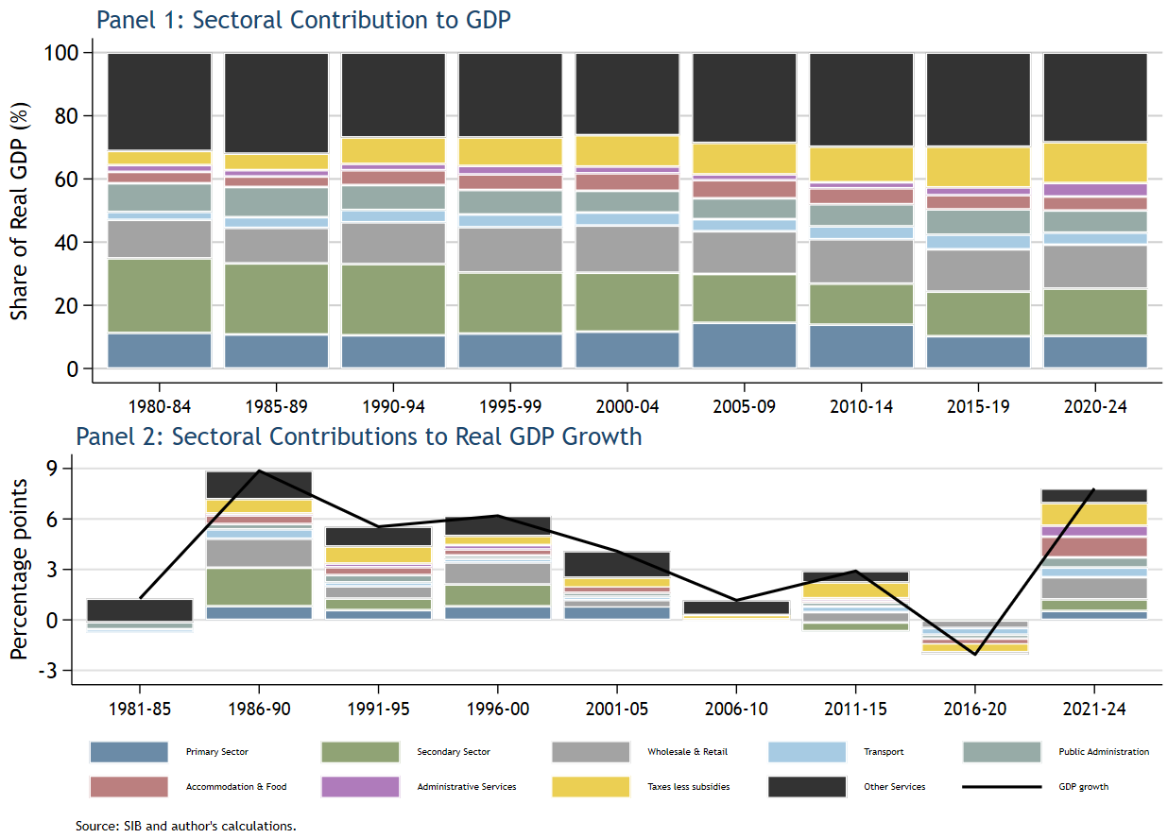

Another notable feature of Panel 1 is the persistently large contribution of “Other Services.” This indicates that a substantial share of economic activity is concentrated in a diverse range of tertiary activities outside the core productive sectors. While services expansion can support employment generation and urbanization, many service activities, particularly non-tradable domestic services tend to exhibit lower productivity growth than manufacturing and technologically advanced tradable sectors. As a result, the structural shift toward services may have supported employment and consumption growth without generating sufficiently strong gains in productivity and export competitiveness.

The rising contribution of taxes less subsidies over time is also noteworthy. This trend may reflect the increasing importance of indirect taxation, import-related tax revenues, tourism-related fiscal receipts, and broader fiscal reforms, including the expansion of consumption-based taxation systems. This suggests that fiscal revenues became increasingly linked to domestic demand and services activity rather than the expansion of productive export sectors.

Panel 2 complements this structural analysis by examining the contribution of sectors to real GDP growth across successive five-year periods. The figure reveals a clear deceleration in long-run economic growth over time. The strongest growth performance occurred during the late 1980s and 1990s, when average real GDP growth exceeded 5 percent and contributions were relatively broad-based across multiple sectors. During this period, the economy benefited from stronger contributions from the primary sector, secondary activities, wholesale and retail trade, and services. This likely reflected a combination of agricultural expansion, tourism growth, investment inflows, and broader macroeconomic stabilization.

In contrast, the post-2000 period is characterized by progressively weaker growth contributions. Contributions from the primary and secondary sectors diminished noticeably, while services became increasingly dominant as drivers of growth. This pattern suggests weakening structural productivity momentum and growing dependence on consumption-oriented and tourism-related activities. Although wholesale and retail trade and accommodation and food services continued to support economic activity, these sectors alone were insufficient to sustain the high growth rates observed in earlier decades.

The 2016–20 period represents the weakest performance in the series and captures the severe economic disruption associated with the COVID-19 pandemic and the collapse in international tourism. Multiple sectors recorded negative contributions to growth, highlighting the vulnerability of Belize’s economic model to external shocks and fluctuations in global tourism demand. The contraction demonstrates the extent to which economic activity had become concentrated in externally dependent service sectors.

The subsequent rebound during 2021–24 reflects the normalization of tourism activity, recovery in domestic demand, and improvements in wholesale and retail trade and other service sectors. However, the composition of the recovery is analytically important. The rebound appears to have been driven primarily by cyclical recovery in services rather than a structural transformation in productive capacity. Contributions from the primary and secondary sectors remained comparatively modest, suggesting that the recovery did not fundamentally alter the underlying growth model.

Overall, the evidence from the two panels suggests that Belize’s development trajectory has been characterized by services-led structural transformation combined with limited industrial deepening and slowing long-run growth performance. While the expansion of services has supported employment creation and economic diversification away from traditional agriculture, the economy remains highly dependent on tourism and domestic services activity. This pattern may help explain the weakening contribution of productivity growth observed in the broader growth accounting analysis and underscores the importance of policies aimed at enhancing productive capacity, export sophistication, resilience, and technological upgrading.

******TOURISM******
The development of tourism services in Belize has contributed significantly to the country’s economic diversification efforts. Over time, however, the economy has become increasingly concentrated in tourism-related activities, positioning the sector as a principal driver of economic growth, employment, and foreign exchange earnings. This high degree of tourism dependence increases Belize’s exposure to business cycle fluctuations and external demand shocks in major source markets, particularly the United States (US) and the European Union (EU).

The rapid expansion of tourism has significantly reshaped the economic landscape of Belize over the past two decades. Estimates from the World Travel and Tourism Council (WTTC) indicate that the sector directly and indirectly accounted for approximately 44.4% of GDP in both 2024 and 2025 and is projected to increase to approximately 53.7% by 2035. Tourism and its ancillary services are projected to have created approximately 67,900 jobs over the same period, equivalent to 42.8% of total employment, underscoring Belize’s high degree of tourism dependence. In contrast, the agricultural sector, while critical for rural livelihoods, its contribution to economic activity has declined over time, falling from 13.0% in 2001 to an estimated 7.9% of GDP in 2024.

The country recorded a five-fold increase in visitor arrivals, rising from 216,932 in 2001 to a peak of 1.09 million (mn) in 2018. Of that total, cruise arrivals on average accounted for around 69.0%. Accordingly, travel receipts have become an increasingly important component of Belize’s external services account, rising from BZ$316.6 mn in 2001 to BZ$2.4 billion (bn) in 2024. This underscores tourism’s role as a critical source of foreign exchange earnings and its importance in supporting the country’s balance of payments position.

Productivity Analysis

The decomposition of Belize’s average annual real GDP growth reveals important shifts in the country’s growth dynamics over the past four decades. Overall, the evidence suggests that Belize’s long-run growth model has been driven primarily by physical capital accumulation and labour expansion, while total factor productivity (TFP) growth has remained volatile and increasingly weak over time. Although periods of rapid expansion were supported by positive gains, more recent decades indicate growing reliance on extensive growth through accumulation of factor inputs rather than sustained improvements in economic efficiency and technological progress.

During the early 1980s (1981-84), Belize recorded relatively weak growth performance, reflecting difficult external economic conditions that affected many Caribbean and Latin American economies during that period (Figure 3). Although physical capital and labour contributed positively to growth, these gains were more than offset by a large negative contribution from TFP. The findings suggest that the economy faced significant inefficiencies in the utilization of productive resources, weak productive capacity and limited technological adoption. In effect, Belize was expanding factor inputs without achieving corresponding gains in productivity.

Figure 3:
Belize Growth Accounting Decomposition (5-Year Avg. Contribution to Real GDP)
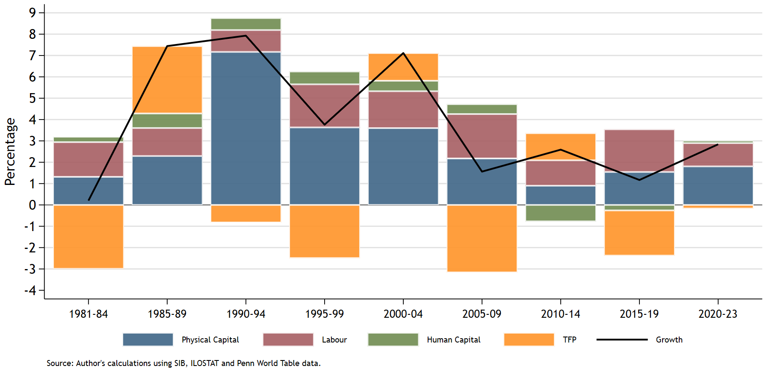

Economic growth accelerated substantially during the 1985-89 and 1990-94 periods, representing the strongest growth episode. This expansion was driven overwhelmingly by physical capital accumulation, particularly during the 1990-94 period when capital contributed more than seven percentage points to annual GDP growth. The surge in capital accumulation likely reflected significant investment in tourism infrastructure, utilities, transportation and expansion in both public and private capital formation. Labour contributions also strengthened steadily during this period, reflecting stronger employment absorption associated with tourism expansion, agricultural activity and service sector growth. Importantly, TFP became strongly positive during the late 1980s, indicating that growth was not solely driven by factor accumulation, but also driven by productive efficiency, structural modernization and improvement in economic organization. This combination of strong investment and positive productivity growth suggests that Belize experienced a temporary phase of relatively dynamic and broad-based economic expansion.

Between 1995 and 2005, Belize’s growth structure became more balanced, although physical capital remained the dominant driver of economic growth. Labour contributions increased noticeably during both the 1995-99 and 2000-04 periods, likely reflecting continued expansion in tourism, construction, wholesale and retail trade, public administration and other services. Human capital also contributed positively throughout the period, although its overall contribution remained modest relative to physical capital and labour. This suggests that while educational attainment and workforce quality may have improved gradually, human capital accumulation did not emerge as a major engine of long-run growth.

A particularly important feature of this period was the increasingly volatile of TFP. Productivity growth turned negative during 1995-99 before recovering during 2000-04. This volatility suggests that Belize’s productivity performance became increasingly vulnerable to cyclical fluctuations, external shocks and structural bottlenecks. The temporary rebound in TFP during the early 2000s may reflect gains associated with tourism expansion, macroeconomic stabilization and enhancement in economic coordination. However, the unstable productivity performance during this period may also have signaled the emergence of deeper structural constraints that became more pronounced in subsequent years.

A major structural shift appears to have emerged after 2005. During the 2005–09 period, TFP became strongly negative and acted as a substantial drag on economic growth despite continued positive contributions from physical capital and labour. This suggests that although Belize continued to expand factor inputs, the efficiency with which these inputs were utilized deteriorated significantly. In other words, growth increasingly relied on extensive expansion through additional labour and capital rather than intensive growth driven by technological upgrading, innovation, and productivity improvements. The deterioration in TFP may reflect several structural constraints facing the economy, including infrastructure bottlenecks, weak technological diffusion, rising informality, declining export competitiveness, institutional inefficiencies, exposure to external shocks, and increasing concentration in relatively low-productivity service activities.

The weakening productivity trend became even more pronounced during the 2015–19 period, when TFP again exerted a large negative contribution to growth. This finding is particularly significant because physical capital and labour continued to contribute positively during the same period. The results therefore suggest declining efficiency in the use of productive inputs and weakening returns to investment. Such patterns are often associated with structural rigidities, weak innovation systems, low technological absorption, and declining allocative efficiency. The findings may also reflect the increasing dependence of Belize’s economy on tourism and domestic services sectors, which can support employment and aggregate demand but may generate weaker long-run productivity gains than manufacturing and higher-value tradable sectors.

Human capital contributions remained consistently positive throughout the entire period but were persistently small relative to the contributions of physical capital and labour. This is an important structural finding because it suggests that Belize has not yet fully leveraged education, workforce upgrading, technological skills, and human capability development as major engines of economic transformation. The relatively weak contribution of human capital may also reflect persistent labour market challenges, including skills mismatches, educational quality concerns, outward migration of skilled workers, labour market informality, and gender disparities in labour force participation and earnings. In the absence of stronger human capital accumulation, sustaining long-run productivity growth becomes increasingly difficult, particularly within a small open economy operating in a rapidly changing global environment.

The 2020–23 period reflects the extraordinary disruption associated with the COVID-19 pandemic and the subsequent recovery. Despite the severe contraction experienced during 2020, the period as a whole still recorded positive contributions from physical capital and labour, reflecting the rapid rebound in tourism activity, employment recovery, reopening effects, and renewed investment activity. TFP during this period appears broadly neutral, suggesting that the recovery was driven more by cyclical normalization and reopening effects than by deeper productivity-enhancing structural transformation. This distinction is important because it indicates that the post-pandemic rebound may not represent a fundamental shift in Belize’s underlying growth model.

Overall, the decomposition highlights several important characteristics of Belize’s development trajectory. First, long-run growth has been heavily dependent on capital accumulation and labour expansion rather than sustained productivity growth. Second, productivity performance has become increasingly volatile and negative over time, suggesting weakening efficiency in the use of productive inputs. Third, human capital accumulation has remained insufficiently strong to emerge as a major source of structural transformation and productivity enhancement. Finally, the findings suggest that Belize may be experiencing the limitations of a services-led growth model that has generated investment and employment growth but has not consistently produced broad-based productivity gains.

The results underscore the importance of policies aimed at enhancing productivity-enhancing structural transformation. In particular, improving infrastructure quality, strengthening institutional efficiency, expanding digitalization, promoting technological adoption, deepening workforce skills, improving educational outcomes, and encouraging diversification into higher-productivity tradable sectors will be critical to sustaining long-run growth. Expanding participation in modern services activities such as business process outsourcing, digital services, logistics, and knowledge-intensive sectors could also help Belize transition toward a more resilient and productivity-driven growth trajectory.

Belize’s long-run economic performance reveals a close relationship between labour productivity and total factor productivity growth, suggesting that improvements in worker output have depended on gains in economic efficiency. Throughout much of the period, the two series moved closely together, indicating that fluctuations in labour productivity were not driven solely by increases in employment or capital accumulation, but also by changes with which labour and capital were utilized across the economy.

Figure 4:
Belize Labour Productivity and Total Factor Productivity Growth
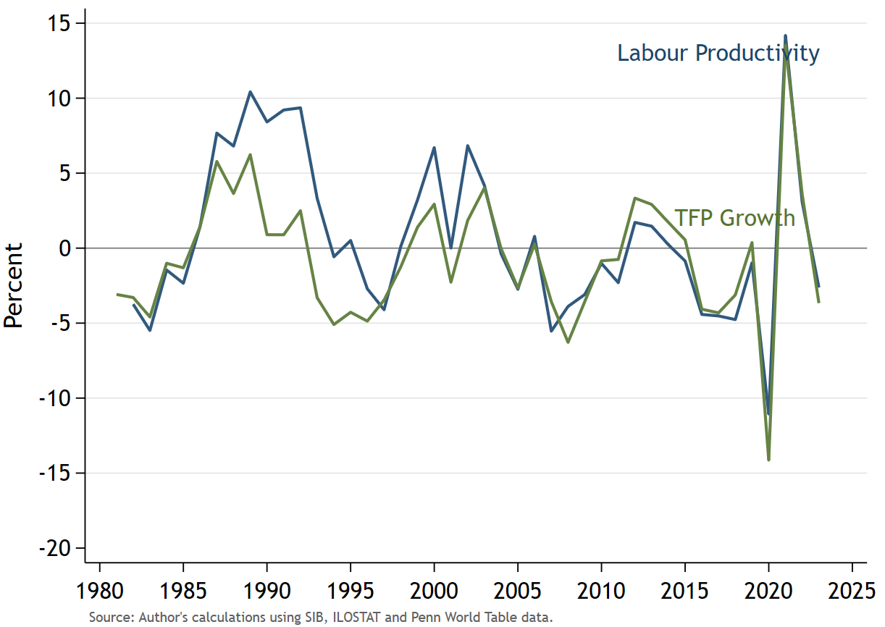

Convergence Analysis

Comparator economies such as Costa Rica, the Dominican Republic, and Mauritius provide a useful benchmark for assessing Belize’s long-term growth trajectory, given their shared structural characteristics as small open economies with varying degrees of tourism dependence and external vulnerability. Real gross national income (GNI) per capita in Belize, measured in purchasing power parity (PPP) adjusted constant international dollars, has remained broadly stagnant over the past three decades. Between 1991 and 2024, the country’s real GNI grew by only 19.3%, reflecting the presence of a persistent middle-income trap dynamics, which is limiting long-term income convergence relative to the selected comparator countries.

In 1991, Belize and Mauritius recorded broadly the same levels of real GNI per capita within the upper-middle-income category. Mauritius’s real GNI per capita was PPP$10,504.25, only PPP$367.63 higher than Belize’s PPP$10,136.62 (Figure 2). In contrast, Costa Rica registered a slightly higher income level, while the Dominica Republic remained at a lower stage of development. However, the subsequent growth trajectories diverged significantly ensuing three decades. Mauritius successfully transitioned to high-income status within eight years through sustained productivity-driven income expansion. Similar, improvements in real GNI per capita were noted for Costa Rica and the Dominican Republic, albeit at a slower pace relative to Mauritius.

In contrast, Belize’s real GNI per capita remained relatively stagnant. Recurrent exogenous shock-related reversals, periods of economic contraction and limited structural transformation are attributed to constraining the country’s convergence toward higher-income peer economies. Between 2006 and 2009, income per capita declined on account of lethargic economic growth exacerbated by inward migration pressures from neighboring Central American countries.

Figure 5:
Gross National Income Per Capita, PPP (Constant 2021 Internation $)
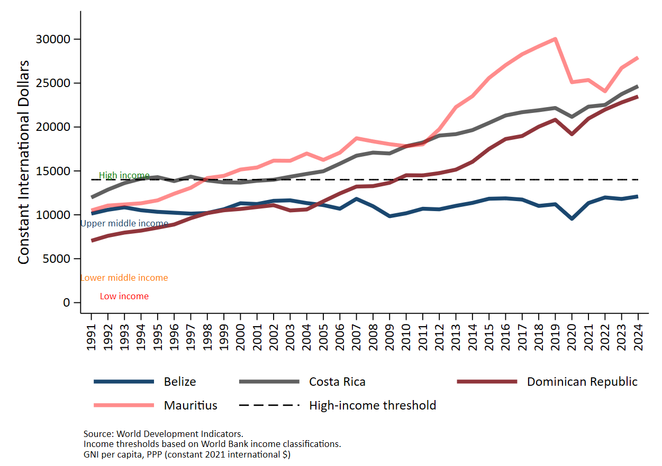
Belize and Selected Comparator Economies

Fiscal, inflation, Debt, external accounts

Demographic and Migration Trends

Belize’s estimated mid-year population in 2026 stood at 426,368, comprising 210,525 males and 217,869 females, implying a gender ratio of approximately 96.6 males per 100 females. Between 2015 and 2026, the Belizean population grew from 356,705 to 426,368, representing cumulative growth of 19.5% or an additional 69,663 persons over the period. This corresponds to an average annual population growth rate of approximately 1.6%.
Bring up population pyramid here.
Contrary to the experience of most small developing states, Belize is becoming increasingly ruralized. As a result, the country is becoming spatially unbalanced, with several districts emerging as key labour supply centers. Over the period of 2015 to 2026, rural population growth outpaced urban growth by approximately three-to-one, with rural population expanding by 52,500 persons, compared with growth of 15,100 persons in urban centers.

The district of Cayo is emerging as a main population growth pole, increasing from 84,629 residents in 2015 to 107,717 in 2026, making it one of the fastest growing regions in Belize. Moreover, rural areas are driving growth within districts. Across Belize’s six administrative districts, population growth was driven primarily by growth in rural areas, except for the Belize District, where population growth in Belize City outpaced that of Belize Rural.
Ethnicity…
The steady growth and ruralization of Belize’s population have important implications for labour market dynamics, the demand for public goods and services, and long-term economic development. An expanding population increases the supply of labour and intensifies pressures on the economy’s capacity to generate productive employment opportunities, particularly for youth entering the labor market. At the same time, sustained population growth raises demand for housing, education, healthcare, transportation, and other public infrastructure, while placing pressure on ecologically sensitive areas. Equally, the trend of rapid ruralization in Belize has consequences for labour market dynamics, poverty reduction efforts and regional economic development. In the absence of sufficient productivity growth and economic diversification, rapid population growth and ruralization may contribute to higher unemployment, underemployment, labour informality and outward migration pressures.

The country’s total dependency ratio stood at 54.7 dependents per 100 working-age persons in 2026, reflecting a relatively youthful demographic structure. The dependency burden is concentrated among the younger cohort of the population, as evidenced by a youth dependence ratio of 43.8%, while the old-age dependency ratio is comparatively low at 10.9%.

The 2026 population pyramid for Belize reveals a demographic structure characterized by a broad concentration of the population within the 10-24 age cohorts (Figure 3). This demographic profile presents an opportunity for Belize to benefit from a demographic dividend, provided the economy can generate sufficient productive employment opportunities supported by sustained investments in the human capital development.

Figure 6:
Population Pyramid: Belize, 2025
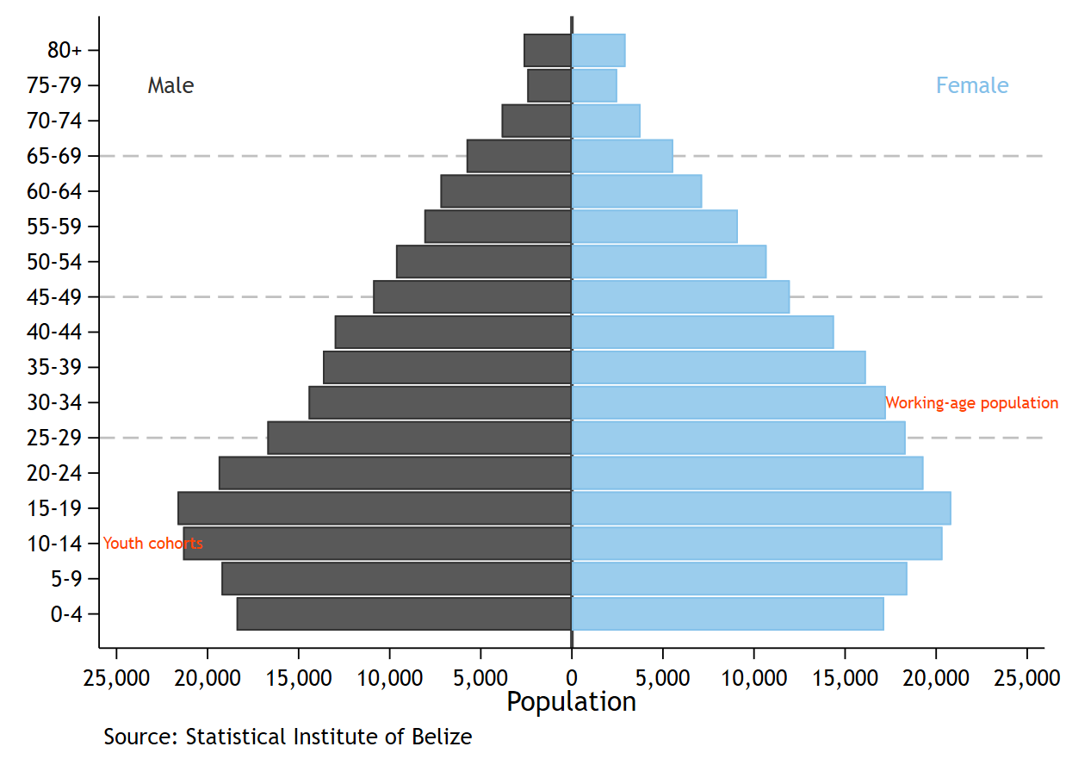

The population pyramid also reveals a gradual narrowing after the 20-24 cohort, particularly across the prime working age group between 25 and 44 years. This pattern may reflect a confluence of outward migration, labour mobility and demographic transition dynamics. The estimated thinning of the economically productive cohorts of the population raises concerns regarding labour retention, skills leakage and the economy’s capacity to sustain long-term productivity growth. For a small open economy such as Belize, these dynamics are macro-critical, as it can weaken human capital deepening and constrain domestic labour market dynamism.

Belize is undergoing a gradual demographic transition, that is characterized by a declining youth share, a rising working-age population and a modest increase in its elderly population. The youth population share; that is person between ages of 0 and 14 years declined from approximately 31.4% of the population in 2015 to about 27.5% in 2025, indicating a gradual reduction in youth dependency pressures (Figure 4). Over the similar period, the working age population (15-64 years) rose from roughly 63.2% to 65.5% of the total population, suggesting the continued expansion of the economically active segment of the population. This shift is particularly important from a labour market perspective, as it increases the potential labour supply and creates the conditions for a possible demographic dividend.

Figure 7:
Belize Demographic Transition, 2015-2025
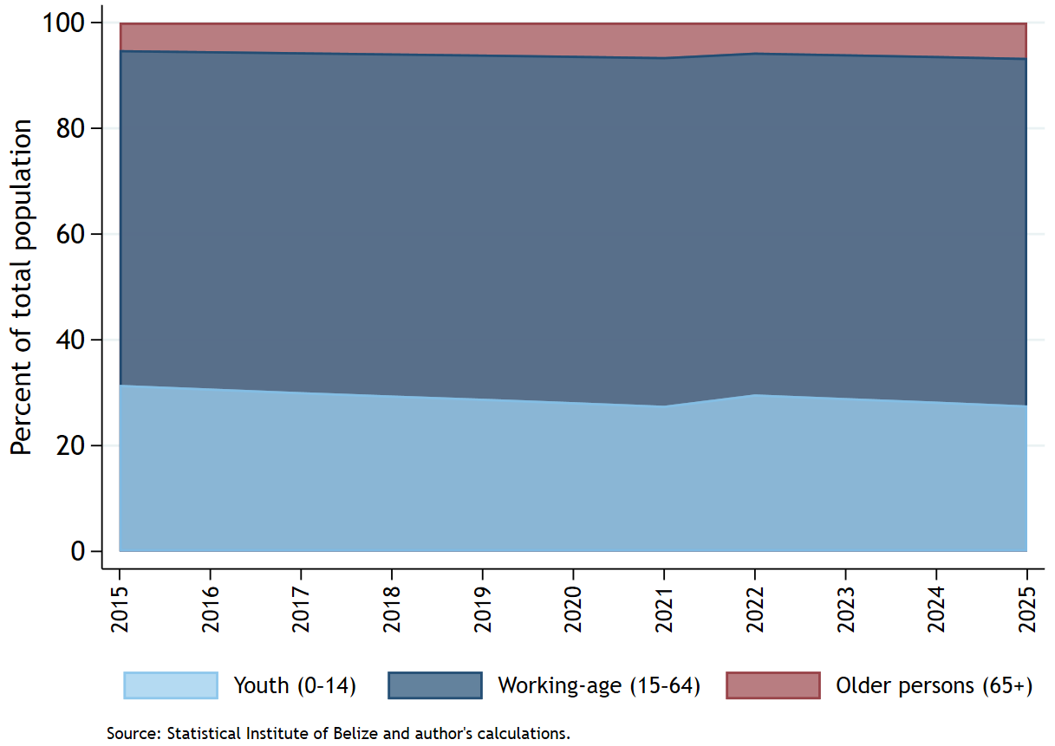

At the same time, the share of older persons rose moderately from around 5.2% in 2015 to approximately 6.6% in 2025, suggesting that Belize remains in the relatively early stages of population ageing compared to more advance economies. The country’s demographic structure, therefore, remains relatively youthful, with comparatively limited old-age dependency pressures. Belize is therefore, currently within a favourable demographic window where the proportion of working-age individuals is increasing relative to dependents.

The demographic structure of Belize reinforces the importance of accelerating structural transformation that facilitates the creation of productivity-enhancing jobs. Given the economy’s high concentration in tourism-related services and relatively modest diversification into higher value-added sectors, the capacity of the labour market to absorb future entrants into productive formal employment remains a critical policy priority.

Belize is currently at a critical stage of its demographic transition, with the evolving age structure of the population presenting a unique potential demographic dividend. Realizing these gains, however, will depend on the country’s ability to strengthen human capital outcomes, expand productive employment opportunities, raise labour productivity and support greater economic diversification and private sector development. Absent sufficient labour market absorption and inclusive economic growth, the expanding working-age population could instead contribute to higher unemployment, labour informality, outward migration, skills depletion and broader socioeconomic pressures.

Belize’s migration dynamics have shifted considerably over the past decades. Following a prolonged period of net outward migration between the 1970s and early 1990s, the country transitioned into a sustained positive net migration position commencing in the mid-1990s. This shift likely reflects expanding economic opportunities associated with the growth of the tourism sector as well as inward migration from neighbouring Central American countries. Net migration flows strengthened during the 2000s, contributing to the expansion of the labour force and total population growth. Migration patterns, however, remain highly sensitive to economic conditions, as evidenced by the sharp decline during the COVID-19 pandemic and the subsequent rebound in 2022. These trends underscore the important role migration plays in shaping Belize’s labour supply, demographic structure and broader development.

The most recently available data from the World Bank indicated that Belize had a diaspora estimated at around 56,223. The majority of the Belizean diaspora resided in the US, that is, 46,336 or 82.4%, followed by Canada and Mexico at 2,146 and 2,127, respectively. For the same period, Belize is estimated to have had 62,043 immigrants, majority of which originated from Central America. Guatemala accounted for the lion share at 26,767, followed by El Salvador at 10,016 and Honduras at 9,784. In line with migration trends, remittance inflows have steadily risen over the years, reaching its peak of BZ$140.1 mn in 2022, highlighting the counter-cyclical nature of inward remittance flows to Belize.

Insert a conclusion paragraph.

Labour Market Assessment

Demographic and Labour Supply Characteristics
Belize’s working-age population has expanded gradually over the past years, increasing from 246,755 persons in 2015 to 312,772 by 2025, equivalent to an increase of approximately 26.8% (Table 1). As a share of the total national population, the working-age population has grown from 66.6% in 2015 to 72.4% in 2024, which corresponds to a 5.7 percentage point increase over the period. The country’s productive-age population is spatially concentrated in rural areas. As of 2024, 56.4% of the working-age population resided in rural areas, with the districts of Belize and Cayo jointly accounting for 54.9%.
The age composition of the working-age population in Belize over the period 2015-2024 suggest that the country’s labour supply is gradually undergoing a demographic transition. While the younger cohorts, particularly persons aged 14-24, continue to account for a significant share of the working-age population, their relative size has begun to decline in recent years (Figure 5). The population aged 14-24 increased from 83,132 persons in 2015 to a peak of 91,200 in 2019, before subsequently declining to 78,849 persons by 2024. This suggests a weakening contribution of younger entrants to the labour supply following the pandemic.

Figure 8:
Belize: Age Structure of the Working-Age Population
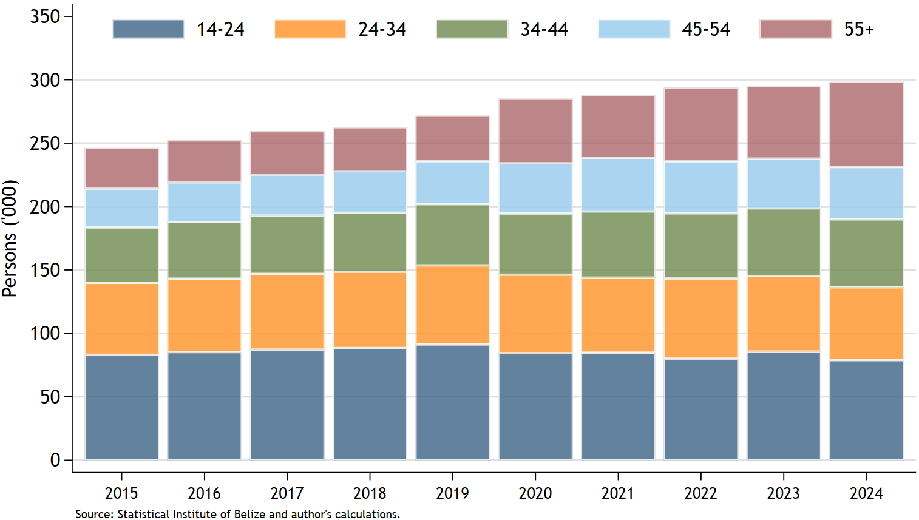
In contrast, the population aged 55 years and above expanded throughout the same period. The size of this cohort more than doubled, increasing from 32,100 persons in 2015 to 67,258 persons by 2024. Particularly notable was the sharp acceleration in growth after 2019, indicating that older persons are accounting for an increasingly large proportion of the working age population. As a result, the age distribution of Belize’s working age population is becoming progressively older, reflecting the combined effects of demographic aging, increased life expectancy and the maturation of older cohorts within the labour force.
The diverging trajectories of younger and older working age populations carry important implications for Belize’s labour market and long-term development prospects. A declining youth share may constrain the future inflow of new labour market entrants, while an expanding older population may place pressure on productivity growth, healthcare systems, social security arrangements and skills adaptation. This points to the importance of strengthening policies aimed at enhancing youth labour market participation, improving skills development and ensuring that older workers remain productively integrated within the economy.

The working age-population is also broadly gender balanced.

Belizean nationals account for approximately 85.0%, while the remaining share primarily originated from neighbouring Central American countries, namely Guatemala, El Salvador and Honduras. In recent years, Belize has been actively working with multilateral organizations like the International Organization for Migration (IOM), the United Nations High Commission for Refugees and regional agencies to strengthen migration governance and refugee management. A key initiative was the Belize Amnesty Programme implemented in 2022, which aimed to regularize undocumented migrants, asylum seekers and long-term residents by providing a pathway to permanent residency and eventual citizenship.

There is growing evidence that migration dynamics have become increasingly important to Belize’s labour market and demographic structure, influencing labour supply, labour force participation, skills composition and population distribution. Accordingly, Belize has also been developing a Migration and Development Policy with support from the IOM and UN agencies. Among the major issues the policy aims to address are the significant immigration from neighbouring Central American countries, particularly Guatemala, Honduras and El Salvador, refugee and asylum flows, labour migration and outward migration of Belizeans to the US and Canada.

Noticeable changes have occurred in the educational attainment profile of Belize’s working-age population between 2015 and 2024, suggesting a gradual improvement in the country’s human capital base. While persons with primary education continued to account for the largest share of the working-age population, the data indicate a steady increase in higher levels of educational attainment, particularly secondary and tertiary education. The population with secondary education increased from 50,037 persons in 2015 to 70,051 persons in 2024, equivalent to 40.0%. Similarly, the number of persons with tertiary education expanded from 35,229 to 54,025 over the same period, representing an increase of nearly 53.4%. This growth in tertiary education attainment suggests a gradual deepening of Belize’s skilled labour force and may reflect expanded access to higher education, increased educational participation and changing labour market demands.

Despite these improvements, the educational structure of the working-age population remains heavily concentrated among persons with lower levels of educational attainments. Individuals with only primary education remained the single largest educational category, increasing from 112,807 persons in 2015 to 120,955 persons in 2024. In contrast the population with no formal education remains broadly unchanged over the period, suggesting some progress in reducing educational exclusion, albeit at a gradual pace.

The evidence points to a gradual process of human capital upgrading taking place in Belize. Although the expansion in secondary and tertiary education is encouraging from a labour productivity and competitiveness standpoint, the continued dominance of primary-level attainment points to persistent structural constraints withing the education and training system in Belize. The composition of educational attainment reflects the economic structure of Belize, which is concentrated in labour intensive low skills sector such as tourism services and agriculture. This is likely to hamper progress towards transitioning Belize towards a more knowledge-intensive and higher value-added economy.

Overall, the evolving educational profile of the working-age population underscores the importance of continued investment in education, technical and vocational training, in Science, Technology, Engineering and Mathematics (STEM), lifelong learning and workforce development policies. Strength the quality, physical and economic access of secondary and tertiary education will be critical to improving labour market outcomes, raining productivity and enhancing Belize’s long-term growth potential.
Figure 9:
Belize: Educational Attainment of the Working-Age-Population
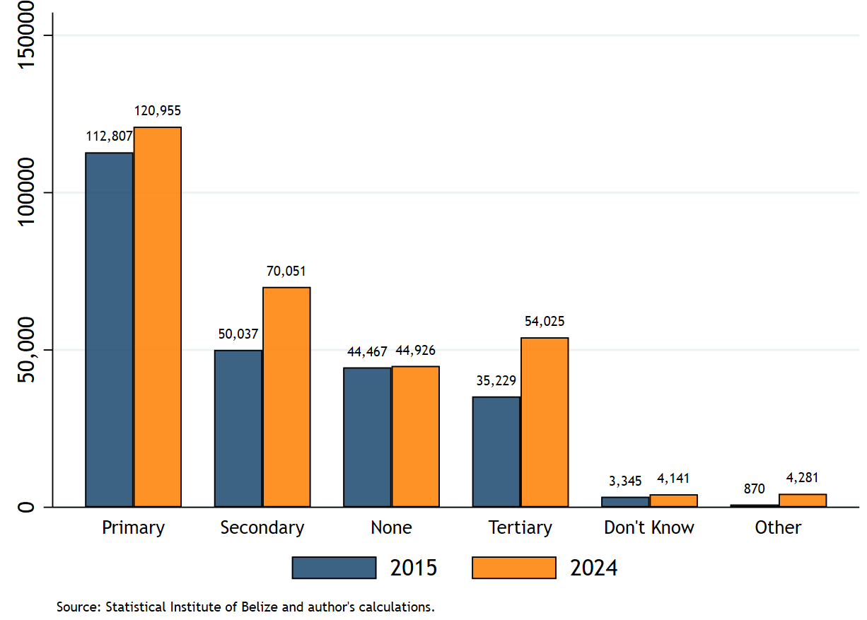

Overall, the evidence suggests that Belize is at an important stage of its demographic and labour market transition. The country continues to benefit from an expanding working-age population and gradual improvements in educational attainment, both of which present opportunities to strengthen productivity, enhance labour market competitiveness and support higher long-term economic growth. At the same time, emerging structural shifts, including the ageing of the working-age population, continued rural concentration and the relatively slow pace of human capital upgrading, highlight the need for targeted policy intervention. Successfully harnessing Belize’s demographic potential will therefore depend on the country’s ability to generate sustained productive employment, deepen investments in education and skills development, improve labour market inclusion and facilitate the transition toward more diversified, knowledge-intensive and higher value-added economic activities.

Labour Force Participation and Utilization
The labour force participation in Belize weakened during the COVID-19 Pandemic period. This was evidenced by the share of persons actively participating in the labour market declining from 190,307 persons in 2019 to 156,456 in 2020, representing a contraction of approximately 17.8%. This decline coincided with the collapse in tourism activity and the broader economic disruptions and social dislocation prompted by the pandemic and the associated containment measures initiated to curtail the spread of the virus. This reduction in labour force participation suggests that the pandemic shock was characterised not only by employment losses, but also by widespread labour market withdrawal, as many individuals became economically inactive rather than remaining actively engaged in job search. Crucially, Belize’s labour force participation in absolute terms has not returned to its pre-pandemic level. As of 2025, the labour force participation was estimated at 181,863, which is equivalent to 95.6% of 2019.

Table 1:
Key Labour Market Indicators Year-on-Year (End of Period=September)
 | 2019 | 2020 | 2021 | 2022 | 2023 | 2024 | 2025
Labour Force | 190,307 | 156,456 | 176,752 | 171,085 | 167,499 | 166,206 | 181,863
Employed | 170,458 | 134,943 | 160,467 | 162,427 | 160,929 | 162,759 | 178,442
Underemployed | 38,769 | 32,163 | 30,479 | 11,054 | 7,203 | 3,555 | 2,498
Unemployed | 19,849 | 21,513 | 16,285 | 8,658 | 6,570 | 3,447 | 3,421
Outside Labour Force | 81,344 | 129,711 | 111,230 | 122,666 | 127,686 | 132,173 | 130,909
Adequately Employed | 131,689 | 102,780 | 129,988 | 151,373 | 153,726 | 159,204 | 175,944

The relatively weak recovery in labour force participation post-COVID-19 becomes more pronounced when assessed against the continued expansion of the working-age population. While the working-age population increased by approximately 26.8% between 2015 and 2025, the labour force remained below its pre-pandemic level as of 2025. This suggests that labour market absorption has not kept pace with the growth in potential labour supply, contributing to rising labour force inactivity and weaker labour market attachment

As a result, the expanding working-age population, combined with a slow post-pandemic recovery in labour force participation, has contributed to a persistent decline in the labour force participation rate (LFPR) in Belize. Prior to the COVID-19 pandemic, the LFPR stood at 70.1% in 2019. However, the pandemic resulted in a contraction in labour market activity, with the LFPR falling to 54.7% in 2020. Although a modest recovery to 61.4% was recorded in 2021 as Belize gradually reopened its economy, labour force participation subsequently weakened, declining to 58.2% by September 2025.

Gender Participation Gap
Belize has had a longstanding and persistent gender labour force participation gap. Although labour force participation rates declined across both sexes during the COVID-19 Pandemic, female participation rates remained consistently and substantially below those of men throughout 2019 to 2024. Before the onset of the pandemic, male labour force participation stood at approximately 81.4% in 2019, compared with 58.9% among women, reflecting a gender participation gap of more than 22 percentage points or 29,639 more men in the labour market than women (Figure 7). While both male and female participation rates contracted in 2020 due to the widespread disruption of economic activity, the recovery in labour market participation has remained uneven and incomplete, particularly among women.

Figure 10:
Belize: Labour Force Participation and Gender Gap
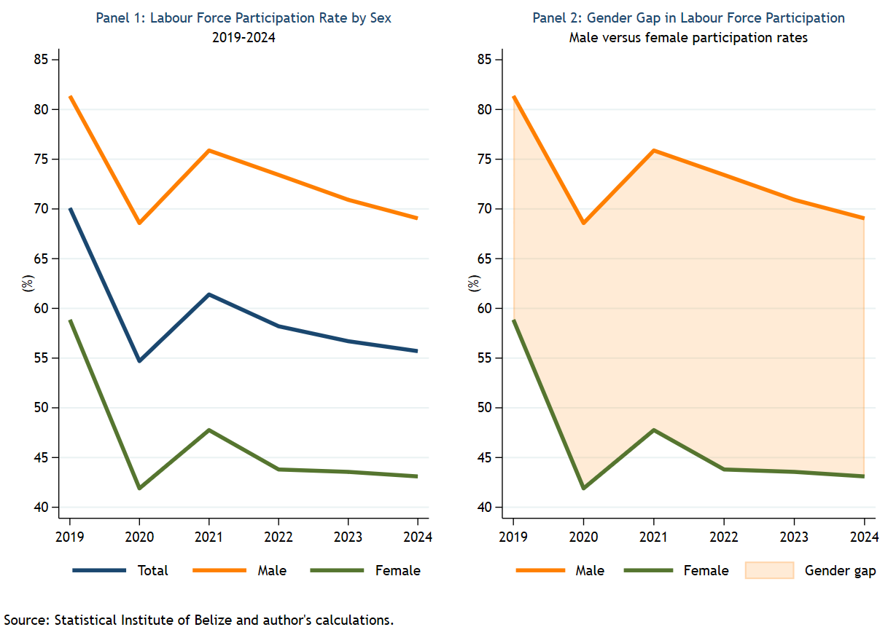

The post-pandemic labour market adjustment in Belize seems to have occurred not only through increases in open unemployment, but also through significant withdrawal of persons from the labour force. This trend appears to have disproportionately affected women. Female labour force participation fell to 41.9% in 2020 and remained persistently weak thereafter, reaching only 43.1% by 2024, well below its pre-pandemic levels. In contrast, male participation rates recovered more strongly following the reopening of the economy, despite remaining below 2019 levels. Consequently, the gender gap in labour force participation has remained persistently elevated throughout the post-pandemic period.

The persistence of this participation gap points to the existence of structural barriers limiting women’s attachment to the labour market. These barriers may include unpaid care and domestic responsibilities, transportation limitations, occupational segregation, informality and restricted access to flexible and productive employment opportunities. The data points to a worrying underutilization of a substantial share of Belize’s female working-age population, notwithstanding the country’s expanding and relatively youthful labour supply.

From a labour market and macroeconomic perspective, the low and declining female labour force participation rate is macro critical and represents an important constraint on labour utilization, productivity growth and the realization of Belize’s demographic dividend. The data imply that improving female labour market participation should constitute a central component of Belize’s employment and growth strategy. Policies aimed at expanding access to affordable childcare services, strengthening transport networks, improving skills development and training opportunities, supporting flexible work arrangements, and facilitating women’s integration into formal and productive employment could play an important role in increasing labour force attachment and improving overall labour market efficiency.

Belize’s labour market institutional and legislative framework according to the World Bank’s Women, Business and the Law report for 2026 presents a mixed and evolving picture as it pertains to women. While the country performs relatively well in areas such as mobility, marriage rights, asset ownership and pension equality, significant gaps remain in labour market legislation, workplace protection, childcare systems, and economic empowerment mechanism for women. It notes that Belize recorded a score of 64.15 for the overall legal framework and a supportive framework score of 53.88, which highlights the persistence of disparities between the formal legal rights enshrined to protect and empower women and practical institutional systems required to support women’s economic participation.

Belize performs strongly in areas related to women’s legal autonomy and civil rights. The country scores 100 in mobility, marriage, and assets under the legal frameworks pillar, reflecting equal rights regarding travel, citizenship, divorce, property ownership, inheritance, and contractual capacity. Belize is also one of the few countries in the Latin America and Caribbean region with legislation directly addressing child marriage. Recent reforms, including the Anti-Sexual Harassment Act (2024) and amendments to the Marriage Act, signal a growing policy commitment toward gender equality and protection against gender-based violence.

However, the report identifies substantial weaknesses in labour market regulation and workplace equality. Belize scores only 25 out of 100 in both the Work legal and supportive framework pillars. The assessment notes the absence of explicit legal prohibitions against discrimination in recruitment based on marital status, parental status, age, or gender, as well as the lack of legislation supporting flexible work arrangements. In addition, the Labour Act still contains restrictions limiting women’s participation in sectors such as mining, construction, manufacturing, agriculture, transportation, energy, and water services. These restrictions may unintentionally constrain female labour force participation and reduce access to higher-paying and traditionally male-dominated occupations.

The report also highlights important deficiencies in care infrastructure and family support systems. Although Belize provides 98 days of paid maternity leave through a combination of employer and government support, there is no statutory paternity leave, and limited policy support exists to encourage shared caregiving responsibilities. Childcare systems also remain underdeveloped, with weak public support mechanisms, limited financial assistance for families, and insufficient regulatory standards for childcare providers. Belize scores only 33.25 in childcare legal frameworks and 25 in supportive frameworks. These constraints likely contribute to lower female labour force participation and higher levels of labour market inactivity among women, particularly mothers.

In entrepreneurship and economic empowerment, Belize demonstrates moderate institutional progress but weak legislative support. While women possess equal legal rights to register businesses, open bank accounts, and sign contracts, the country lacks explicit protections against gender discrimination in access to credit, gender-responsive procurement legislation, and quotas for female representation on corporate boards. Nonetheless, supportive initiatives such as BELTRAIDE programs and the Belize Enterprise Revolving Fund provide some institutional backing for women entrepreneurs.

The findings of the report suggest that Belize has made important advances in formal legal equality and social protections but continues to face structural gaps in labour market institutions, workplace protections, childcare systems, and gender-responsive economic policies. The evidence points toward the need for a second generation of reforms focused not only on legal rights, but also on implementation, labour market inclusion, care infrastructure, data systems, and institutional enforcement mechanisms capable of translating formal equality into meaningful economic participation and productivity gains.

Employment Trends
Belize’s labour market experienced a severe disruption during the COVID-19 pandemic, followed by a gradual improvement in labour utilization conditions during the post-pandemic recovery period. The decomposition of the labour force into adequately employed (persons working XXX hours weekly), underemployed and unemployed persons highlights that the recovery was characterized not only by rising employment levels, but also by a marked improvement in quality and adequacy of employment among labour market participants.
Preceding the pandemic, Belize’s labour market already exhibited notable levels of underutilization. In 2019, approximately 131,689 persons were adequately employed, while 38,769 persons were underemployed and 19,849 persons were unemployed. This indicates that although employment levels were relatively strong, a sizeable proportion of workers remained engaged in insufficient or unstable forms of employment. Total employment, measured as a sum of adequately employed and underemployed persons, stood at approximately 170,000 persons.
The onset of the pandemic in 2020 resulted in a deterioration in labour market conditions. Adequately employed persons declined to approximately 107,780 persons, while underemployed and unemployed persons remained elevated at 32,163 and 21,513 persons, respectively. Total employment fell to approximately 135,000 persons, reflecting the collapse in tourism activity, reduced business operations and broader economic disruptions associated with pandemic and the related containment measures. This contraction illustrates the magnitude of the labour market shock and reflects the vulnerability of Belize’s labour market and economy to external demand shocks, particularly given the country's high dependence on tourism and tourism-related services.
Importantly, the labour market adjustment was not driven solely by open unemployment. The persistence of elevated underemployment during this period suggests that many workers remained partially attached to the labour market through reduced working hours, irregular work arrangements or insufficient income-generating opportunities.
From 2021 onward, Belize experienced a gradual but sustained labour market recovery. The most noticeable feature of this recovery was the rapid expansion of adequately employed persons. Adequate employment rose from around 130,000 persons in 2021 to nearly 176,000 persons in by 2025, surpassing pre-pandemic levels, with an estimated 44,256 persons being gainfully employed (Figure 8). At the same time, both underemployment and unemployment registered contractions. Underemployment fell from 30,479 persons in 2021 to 2,498 persons by 2025, while unemployment declined from 16,825 to 3,421 persons over the same period. As a result, total employment recovered steadily, rising to approximately 178,000 persons by 2025, which is equivalent to around 8,000 more persons employed in Belize relative to 2019.

Figure 11:
Belize Composition of the Labour Force Disaggregated by Employment Quality
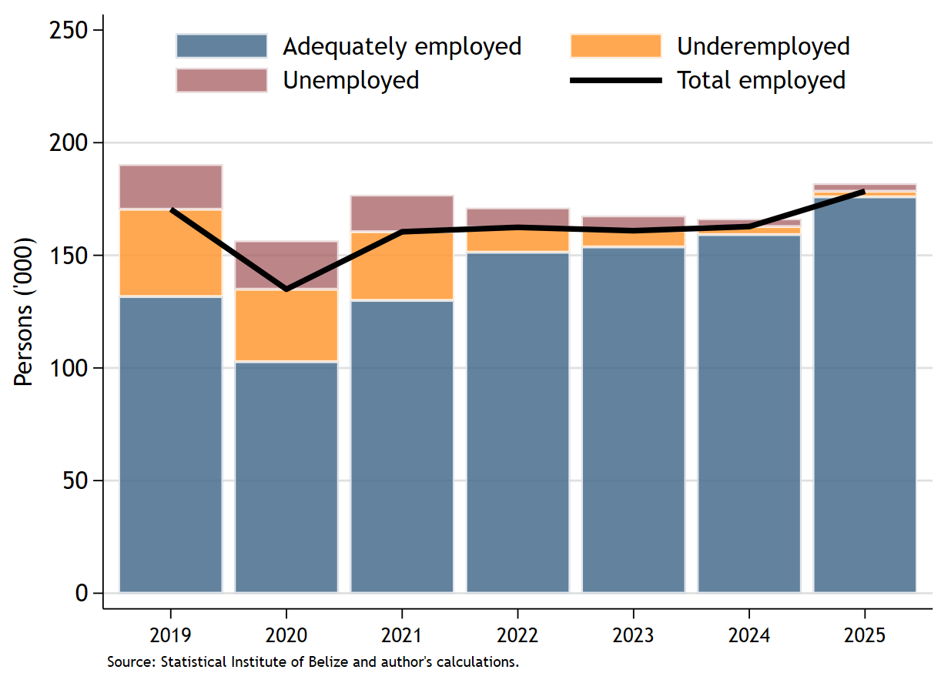
The sharp reduction in underemployment is particularly significant from a labour market perspective. While unemployment captures persons actively seeking work but unable to secure employment, underemployment reflects a broader form of labour underutilization whereby individuals remain employed but lack sufficient hours of work or productive engagement. The substantial decline in underemployment therefore suggests that the post-pandemic recovery was increasingly associated with improvements in the intensity, stability and adequacy of employment rather than merely a numerical increase in jobs. In this regard, Belize’s labour market recovery appears to have become progressively more employment intensive and productivity-supportive over time.
More emphasis on unemployment by youth, district, ethnicity and NEETS
Despite the improvements noted in labour utilization conditions, the findings should be interpreted alongside the broader demographic trends affecting the labour market. Although employment quality improved and labour underutilization declined, labour force participation rates remain below pre-pandemic levels relative to the continued expansion of the working-age population. This suggests that structural labour market challenges persist, particularly with respect to labour market attachments, labour absorption capacity and inclusive participation across different demographics groups, especially women and younger workers.

More broadly, the data underscores the importance of examining labour market performance beyond conventional unemployment indicators. While unemployment remains an important measure of labour market conditions, the sustained rise in labour force inactivity, particularly among women, suggests that labour underutilization in Belize increasingly manifests through labour force detachment rather than solely through open unemployment.

Sectoral Decomposition of Employment
The changing composition of employment in Belize between 2019 and 2025 points to an ongoing structural transformation within the labour market, characterized by a gradual shift away from traditional productive sectors toward a more service-oriented employment structure. While wholesale and retail trade remained the single largest identifiable source of employment throughout the period, the relative importance of several sectors evolved considerably in response to the COVID-19 pandemic, the subsequent economic recovery and changing patterns of labour demand.
Prior to the pandemic, tourism, distributive trade and agriculture accounted for relatively large shares of total employment, reflecting Belize’s dependence on external tourism demand, domestic demand and primary sector activity. However, the onset of the COVID-19 pandemic in 2020 resulted in a contraction in tourism-related employment, with the sector’s share of total employment falling significantly as international travel restrictions and the collapse on visitor arrivals disrupted labour demand. At the same time, government services and agriculture increased in relative importance, suggesting that these sectors function as temporary labour absorbers during the crisis period.
The post-pandemic period has been characterized by a gradual recovery of tourism and community-based services, alongside a decline in a relative contribution of agriculture to total employment. By 2025, tourism had largely regained its position as one of the dominant sectors within the labour market, underscoring Belize’s continued dependence on externally driven service-sector activity. Community and social services also recorded an increase in employment share over the period, reflecting the broader expansion of service-oriented economic activity within the Belizean economy.
One of the more notable developments is the sustained increase in the other category, which expanded from approximately one-fifth of total employment in 2019 to more than one-quarter by 2025. This is suggesting that a growing share of employment is emerging outside Belize’s traditional sectors. Although the category is not disaggregated within the available data, it is plausible that part of this increase reflects the expansion of newer service-based activities, including business process outsourcing (BPO), call centers, digital support services and other administrative and back-office support services. The country has increasingly positioned itself as a destination for English speaking outsourcing services within the region, supported by relatively low labour costs, geographic proximity to North America, a population that speaks both English and Spanish and expanding digital connectivity.
The growth of these activities may indicate the gradual emergence of a more diversified urban services economy, particularly among younger workers and secondary urban centres. However, the absence of more granular labour market data constrains a precise assessment of the extent to which BPO, and other modern service industries are driving this trend. This points to an important data and policy gap within Belize’s labour market monitoring framework, particularly given the growing importance of non-traditional services and digital enabled employment.
Figure 12:
Share of Employed Persons by Main Industry
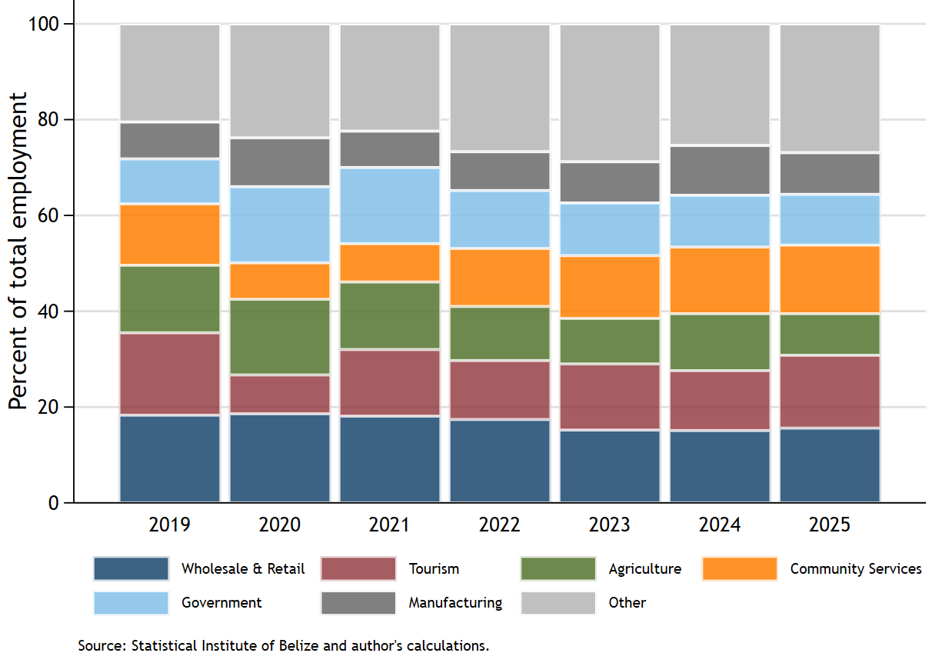

Overall, the evolving employment structure suggests that Belize’s labour market is becoming increasingly service-driven, with labour progressively reallocating away from agriculture and toward tourism, distributive trade, community services and potentially newer digitally enabled services activities. While this transformation may create new employment opportunities, it also reinforces concerns regarding economic concentration, labour market vulnerability and productivity. Many of the expanding sectors remain highly exposed to external shocks, cyclical tourism demand and relatively low productivity service activities. Consequently, the findings reinforce the importance of policies aimed at economic diversification, productivity upgrading, skills development and the expansion of higher value-added forms of employment capable of improving labour market resilience and long-term income growth.

Unemployment Trends
Total, Male, Female, Youth, BY District

Labour Force Inactivity
The decline in labour force participation has coincided with a substantial increase in the number of persons remaining outside the labour force. The economically inactive working-age population increased from 81,344 persons in September 2019, equivalent to approximately 29.9% of the working-age population, to 130,909 persons by September 2025, representing approximately 41.9% of the working-age population. Overall, the number of economically inactive persons increased by 49,565 persons between 2019 and 2025, equivalent to a cumulative increase of approximately 60.9%.

This sustained rise in labour force inactivity post COVID-19 suggests that the labour market adjustments in Belize has increasingly occurred through labour force withdrawal rather than through open unemployment. This trend raises important concerns regarding labour underutilization, the economy’s capacity to productively absorb its expanding working-age population, and the country’s ability to fully realize the demographic dividends.

Women are disproportionately represented among persons outside the labour force in Belize. This represents a persistent and significant gender participation gap within the labour market (Figure 6). Throughout the period 2019 to 2024, females consistently accounted for the majority of economically inactive persons, with the number of women outside the labour force substantially exceeding that of men in every year observed. This suggests that the labour market inactivity in Belize is not gender neutral, which places women at a significantly economically disadvantaged position.

Figure 13:
Belize: Persons Outside the Labour Force by Sex
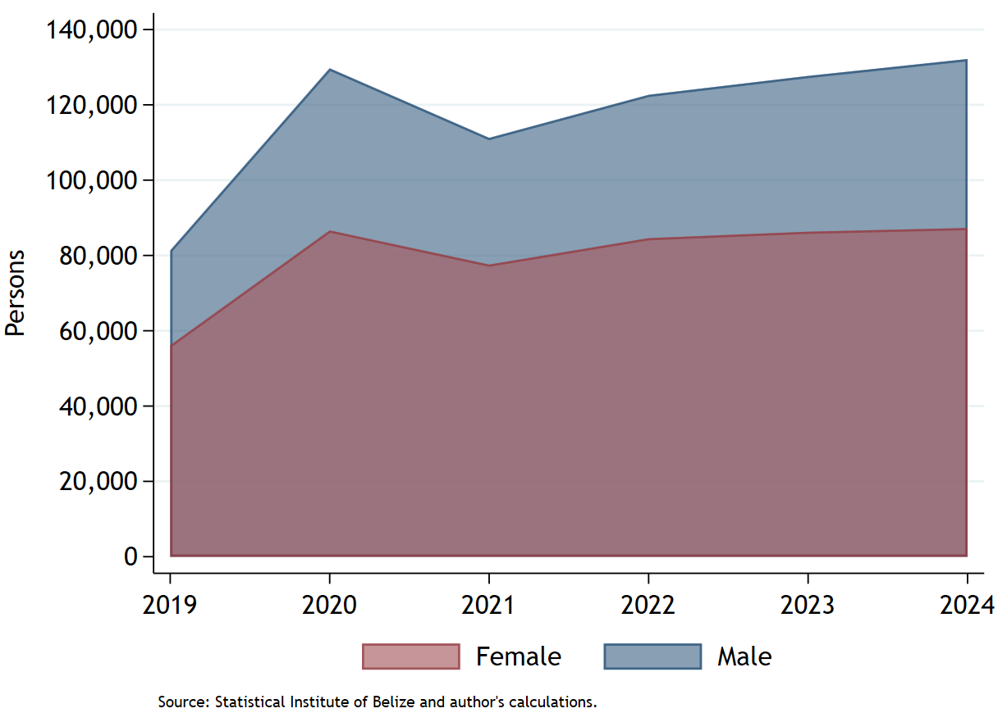
The COVID-19 pandemic appears to have exacerbated these pre-existing disparities. Between 2019 and 2020, the number of women outside the labour force increased sharply from approximately 56,158 persons to 86,670, representing an increase of more than 54.0%. Although male inactivity increased during the same period, female inactivity remained considerably higher throughout the post-pandemic period. Importantly, despite the gradual reopening of the economic and the recovery in economic activity following the pandemic, the number of women outside the labour force remained persistently elevated, suggesting that female labour market attachment recovered at a slower pace relative to men.

These findings imply that labour market adjustment during and after the pandemic occurred disproportionately through female labour force withdrawal rather than sole through increases in open unemployment. This may reflect the presence of structural barriers limiting female participation in economic activity, including unpaid care responsibilities, childcare constraints, transportation limitations, labour market segmentation, occupational segregation, discouragement effects and limited access to flexible of formal employment opportunities. Given Belize’s relatively youthful and expanding working-age population, the continued exclusion of a large share of women from economic activity represents a significant source of untapped labour potential within the economy. This represents a significant risk to Belize capitalizing on its demographic dividend.

From a broader macroeconomic perspective, persistently high female labour force inactivity may constrain labour utilization, productivity growth, household income generation, and the country’s ability to fully capitalize on its demographic dividend. These findings therefore underscore the importance of policies aimed at strengthening female labour market participation through investments in childcare services, transportation infrastructure, skills development, flexible work arrangements, and broader labour market inclusion initiatives.

Wages Structure

See Inter-American Development Bank (IDB), Rekindling Growth in Belize.
International Monetary Fund Article IV Staff Report 2025.
According to the Office of the Prime Minister and the Ministry of Investment, Belize’s BPO sector is estimated to employ approximately 20,000 persons.
Belize is ranked 15th globally as the most tourist dependent country in the world according to the Inter-American Development Bank.
The estimated average global dependency ratio in 2025 was 58.4%.
2021

